**[Core-Fundamental-Project](https://github.com/MIhsanA/Core-Fundamental-Project)**

Content

* Brief
* Links
* My Approach
* Planning
* Development
* Technology’s used
* End result
* Room for improvement

**Brief**

Create A python flak app on any subject you deem fit. Using SQL Database.

Database should have two tables with one relationship.   
of encapsulating all aspects of the aforementioned modules.

Your overall objective with this project is the following:

### To create a CRUD application with utilisation of supporting tools, methodologies and technologies Python, flask, MySQL, Pytest, Jenkins, Cloud Concepts, Git, etc.

* Objectively assess your capability with the technologies
* Assess your development against SFIA.

**Links**

Risk Assessment link

<https://docs.google.com/spreadsheets/d/1kJK4JxCoMXqOS6U0VTs0-iOHTLHc1YL_pbm0T2j-Tmc/edit#gid=0>

Wed app

Running on Jenkins

<http://35.230.133.159:5000/home>

**My Approach**

I want to create a cricket related app. Where user can save stats for his team and other teams. And user can use this app during the match to score a match and database gets updated along with the game results

**Planning**

I started with a lot of the functionalities for my app but as my project progressed I had to drop a lot of features and change some.

## Project Tracking

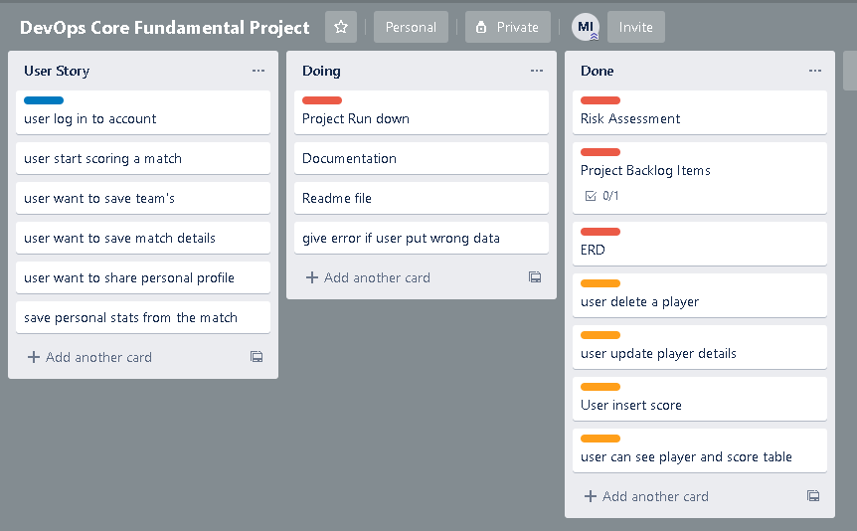

I used **Trello** to keep track of my project I moved the cards in their state of development.

MoSCoW

Because my project had a lot of functions I did a Moscow board to stay on top project requirements

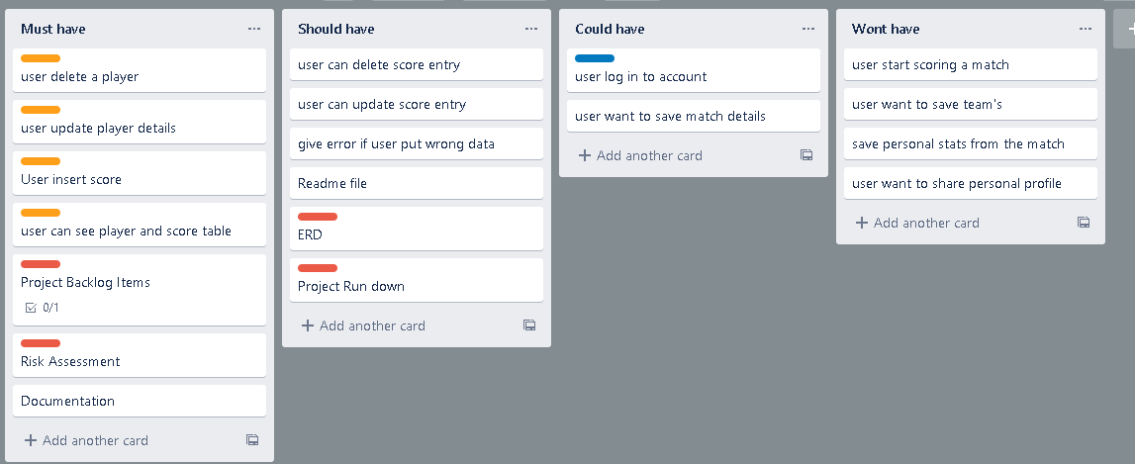

**ERD**

My Database ERD changed over time as I progressed through the project.

Blow are the different stages for my ERD and final one I used for my project

**1st Design**

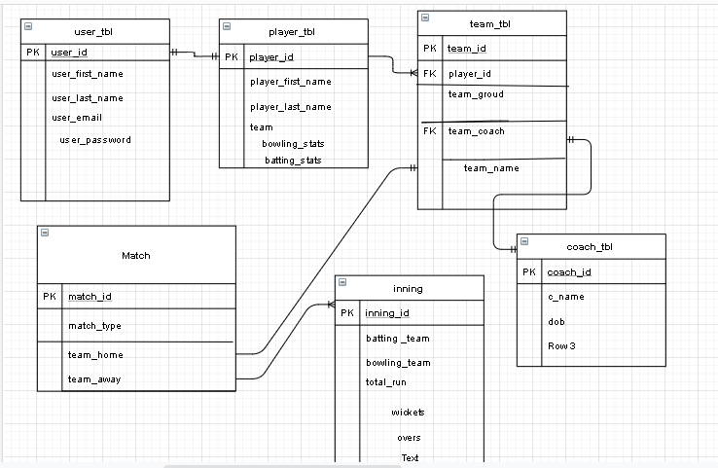

**2nd design**

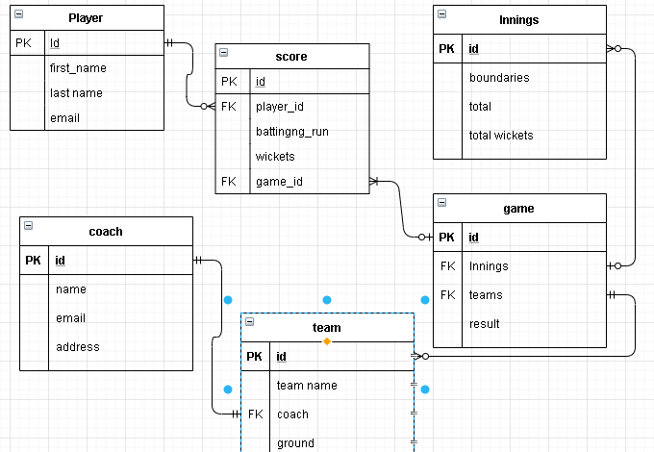

**Final ERD**

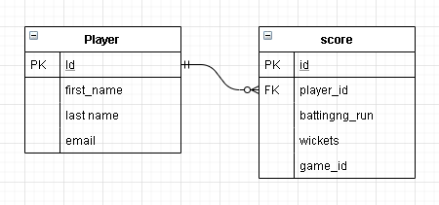

**Testing**

I did testing for my project as it progressed. pytest is used to run unit tests and Integration test on the app below are some reports

**Result 1**

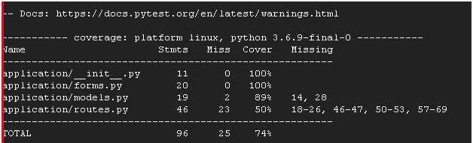

**Result 2**

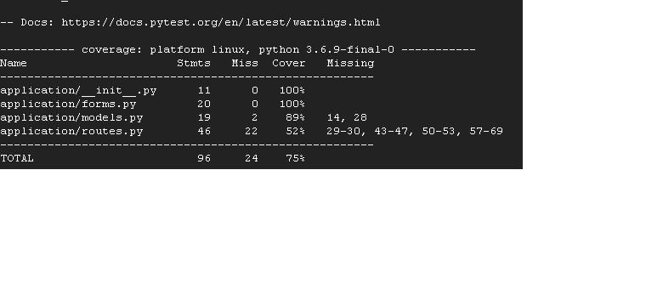

**Result 3**

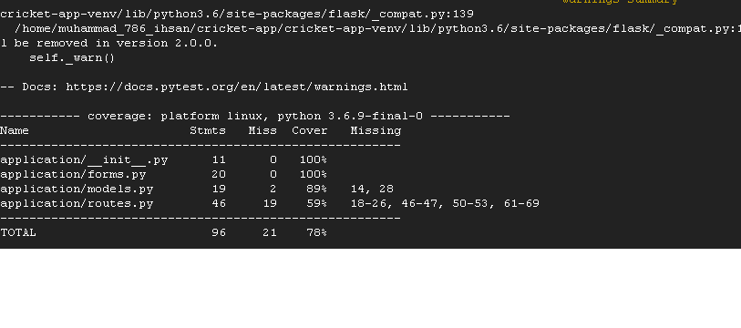

**Result 4**

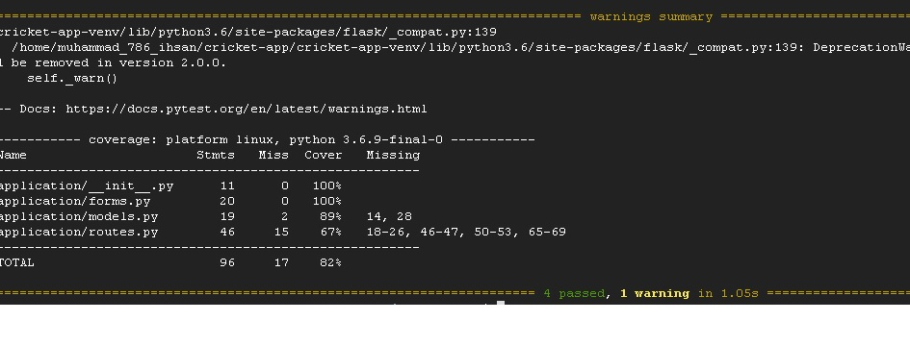

**Flask Integration Testing**

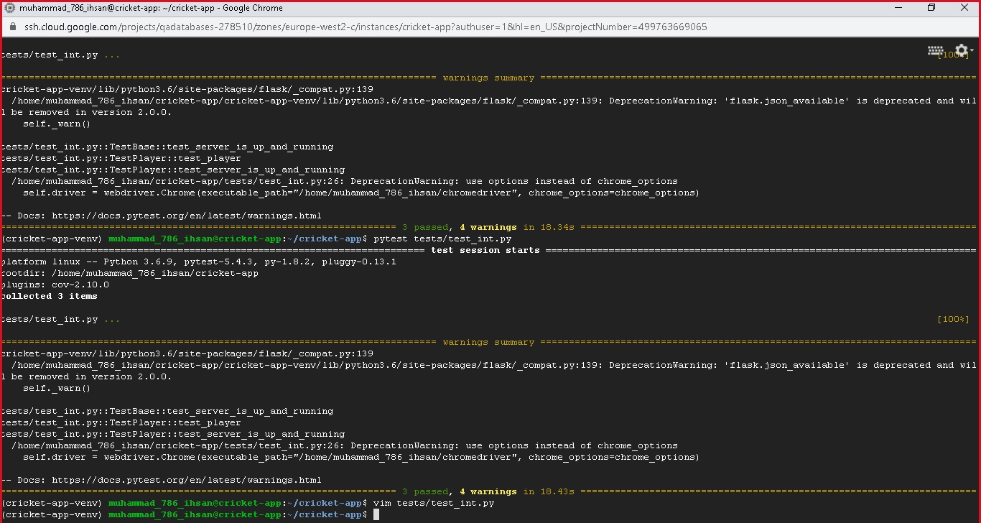

**Risk Assessment**

my risk Assessment can found on the link blow and screen shot is also added.

link <https://docs.google.com/spreadsheets/d/1kJK4JxCoMXqOS6U0VTs0-iOHTLHc1YL_pbm0T2j-Tmc/edit#gid=0>

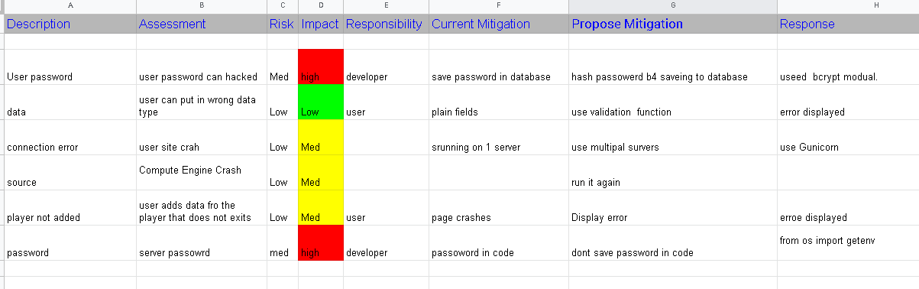

**Technology’s used**

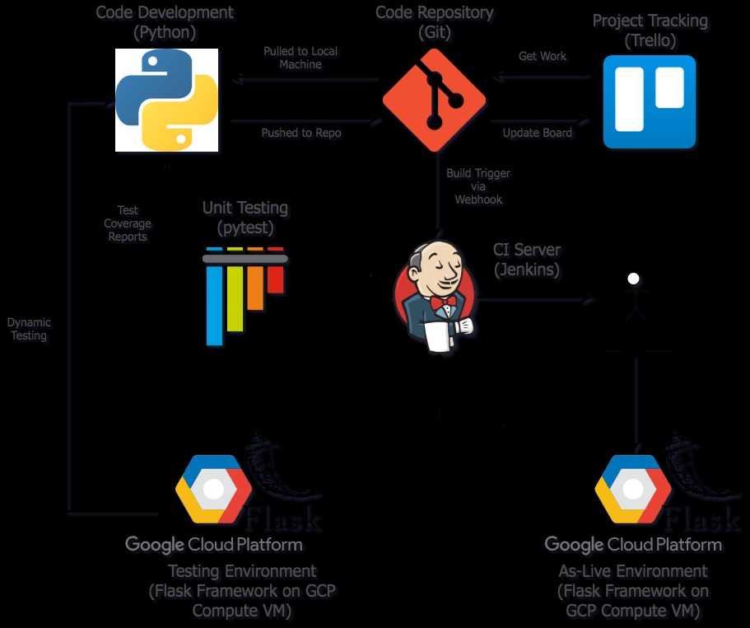

**End result**

**Home Page**

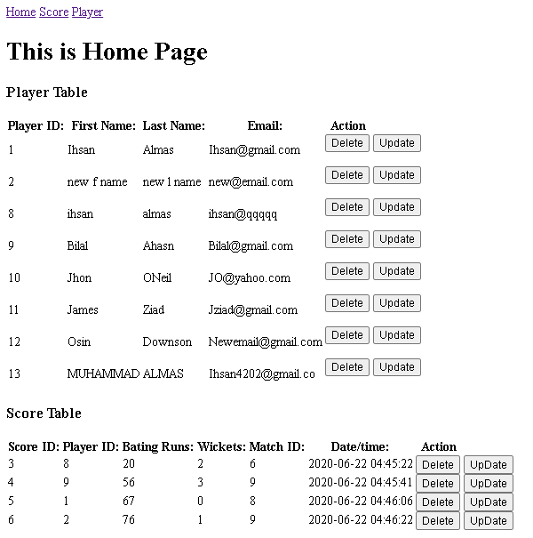

**Score Page**

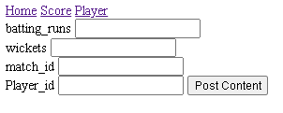

**Player page**

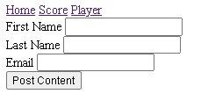

**Player update page**

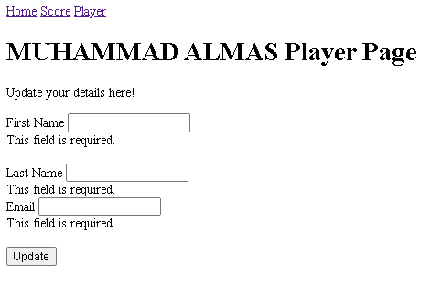

**Room for improvement**

we can create team table and keep record for each team

we can add in functions to manipulate data e.g. delete score entry

we can display stats for each player

we can display better error messages.